Primary Keys and Foreign Keys

In a relational database like MySQL, Primary Keys (PK) and Foreign Keys (FK) are the tools used to create connections between tables while keeping data organized and accurate.

1. What is a Primary Key (PK)?
A Primary Key is a unique identifier for every record in a table. Think of it like a Social Security Number or a Passport Number; it ensures that no two rows are exactly the same.
- Rules:
  - Uniqueness: No two rows can have the same Primary Key.
  - Not Null: It cannot be empty. Every row must have a key.
  - One per Table: A table can only have one primary key.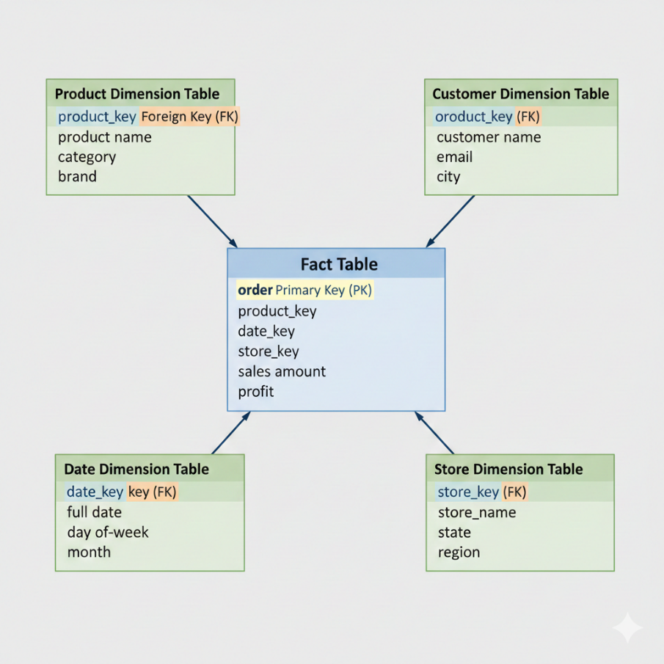
2. What is a Foreign Key (FK)?
A Foreign Key is a column in one table that points to the Primary Key of another table. It acts as a "link" or "connector" between them.
- Rules:
  - Referential Integrity: You cannot add a value to an FK column if it doesn't already exist in the parent table's PK column.
  - Duplicates Allowed: Multiple rows can have the same Foreign Key (e.g., one customer can have many orders).
  - Nulls Allowed: Unlike a PK, a Foreign Key can sometimes be empty (unless you specify NOT NULL).

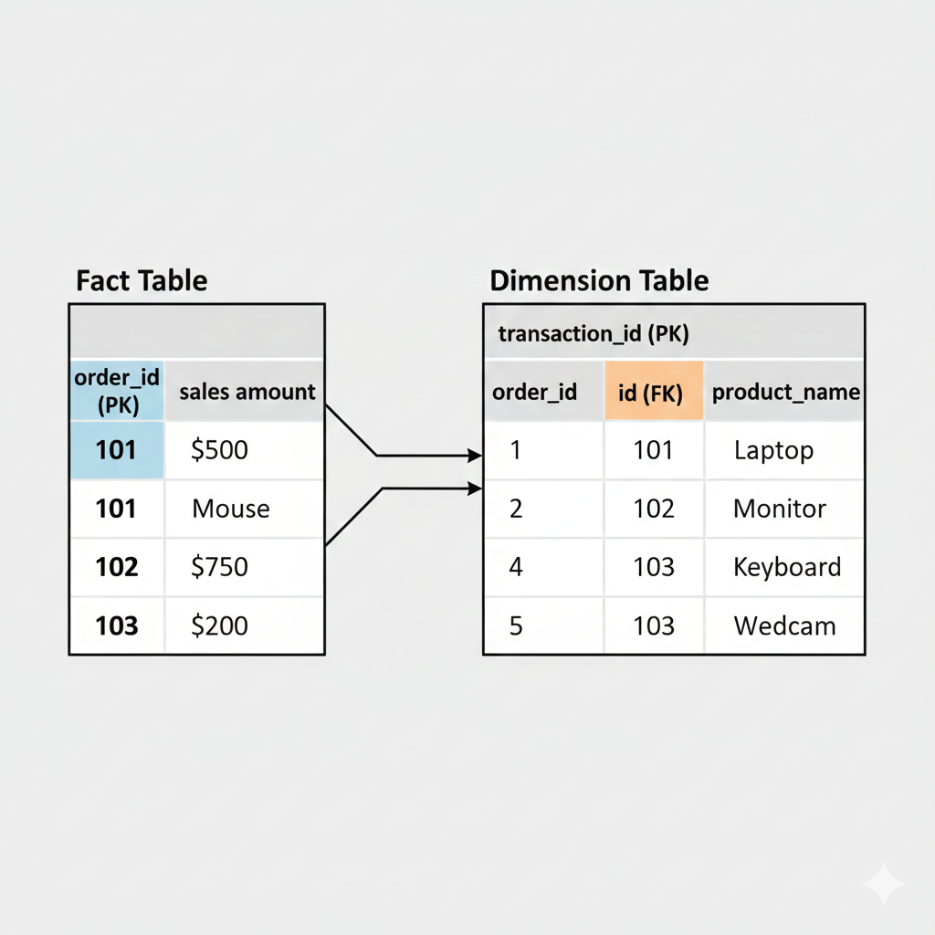
3. Creating the Relationship (MySQL Example)
Imagine a "Parent" table of Authors and a "Child" table of Books. One author can write many books—this is a One-to-Many relationship.
Step 1: Create the Parent Table
CREATE TABLE Authors (
author_id INT AUTO_INCREMENT PRIMARY KEY, -- Primary Key
author_name VARCHAR(100) NOT NULL
);
Step 2: Create the Child Table with a Foreign Key
CREATE TABLE Books (
book_id INT AUTO_INCREMENT PRIMARY KEY,
title VARCHAR(150) NOT NULL,
author_id INT, -- This will be our Foreign Key

-- Link this column to the Authors table
FOREIGN KEY (author_id) REFERENCES Authors(author_id)
);

4. Why use them? (Data Integrity)
Using these keys prevents "orphan" data. For example:
- Preventing Errors: MySQL won't let you add a book for author_id = 99 if that author doesn't exist in your Authors table.
- Cascading Actions: You can set rules like ON DELETE CASCADE. This means if you delete an author, MySQL will automatically delete all their books for you, keeping your database clean.

To test how Primary and Foreign Keys maintain data integrity, we will use a Parent table (Authors) and a Child table (Books).
1. Setup the Tables
First, run these queries to create the relationship. Note the ON DELETE CASCADE line—this is what links the fate of the books to their authors.
-- Parent Table
CREATE TABLE Authors (
author_id INT PRIMARY KEY,
author_name VARCHAR(100)
);

-- Child Table
CREATE TABLE Books (
book_id INT PRIMARY KEY,
title VARCHAR(100),
author_id INT,
FOREIGN KEY (author_id) REFERENCES Authors(author_id)
ON DELETE CASCADE -- This enables cascading
);

2. Test: Preventing Errors
The Foreign Key constraint prevents you from adding a book for an author who doesn't exist.
Step A: Add a valid author
INSERT INTO Authors (author_id, author_name) VALUES (1, 'J.K. Rowling');
Step B: Try to add a book for a non-existent author (The Error Test)
-- This will FAIL because author_id 99 does not exist in the Authors table
INSERT INTO Books (book_id, title, author_id)
VALUES (101, 'Fake Book', 99);
What happens? MySQL will throw an error: Cannot add or update a child row: a foreign key constraint fails.

3. Test: Cascading Actions
"Cascading" means if you delete a row in the parent table, MySQL automatically cleans up the related rows in the child table.
Step A: Add valid books for our author
INSERT INTO Books (book_id, title, author_id) VALUES (201, 'Harry Potter 1', 1);
INSERT INTO Books (book_id, title, author_id) VALUES (202, 'Harry Potter 2', 1);
Step B: Delete the Author and watch the cascade
-- Delete the author from the Parent table
DELETE FROM Authors WHERE author_id = 1;

-- Now, check the Books table
SELECT * FROM Books;
The Result: Even though you didn't delete the books manually, the Books table will now be empty. Because of ON DELETE CASCADE, MySQL realized the author was gone and automatically removed all books linked to that author_id.

